Name: Astha Arpit Bhatt

Enroll: 196140316006

**Practical 12**

**Develop a Graphical User Interface that performs the following SQL operations: a) Insert b) Delete c)Update.**

1. **Insert:**

package studentdb;

import java.sql.*;

public class Studentdb {

public static void main(String[] args) {

try{

Class.forName("com.mysql.jdbc.Driver");

Connection con = DriverManager.getConnection("jdbc:mysql://localhost:3306/studb","root","");

Statement stmt = con.createStatement();

String qry = "insert into studb value(5,'Riya',19)";

stmt.executeUpdate(qry);

System.out.println("Record insert successfully");

con.close();

}

catch(Exception e){

}

}

}



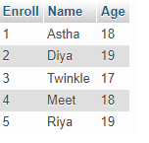

1. **Delete**

package studentdb;

import java.sql.Connection;

import java.sql.DriverManager;

import java.sql.Statement;

import java.util.Scanner;

public class Deleterecord {

public static void main(String args[])

{

try

{

Class.forName("com.mysql.jdbc.Driver");

Connection con = DriverManager.getConnection("jdbc:mysql://localhost:3306/studb","root","");

Statement stmt = con.createStatement();

int rno;

Scanner sc = new Scanner(System.in);

System.out.println("Enter rno to delete record");

rno=sc.nextInt();

String qry = "delete from studb where Enroll=" +rno;

stmt.executeUpdate(qry);

System.out.println("Record deleted successfully");

con.close();

}

catch(Exception e)

{ }

}

}

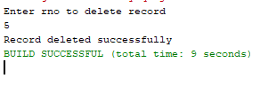

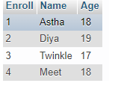

1. **Update**

package studentdb;

import java.sql.Connection;

import java.sql.DriverManager;

import java.sql.Statement;

public class Updaterecord {

public static void main(String args[])

{

try

{

Class.forName("com.mysql.jdbc.Driver");

Connection con = DriverManager.getConnection("jdbc:mysql://localhost:3306/studb","root","");

Statement stmt = con.createStatement();

String qry = "update studb set Age=22 where Enroll=2";

stmt.executeUpdate(qry);

System.out.println("Record updated");

con.close();

}

catch(Exception e)

{}

}}



Before update:

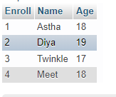

After update:

